Spot Awards - Department Guide

Guidelines: Each person can have no more than three per calendar year, $75 per award.

- The nominator needs to fill out the form. Once filled out, the nominator needs to send it to the Department/Program manager.
- The Department/Program manager then needs to send the form to the Department chair and April Kerkes (funding) for approvals. (Divisional Spot Awards should still be sent to Academic HR Specialist Lili Diaz (liivdiaz@ucsc.edu).)
- The Department/Program manager can send the email letting the recipient know of their Spot Award once approvals are obtained. CC the nominator as well. Here is an email template:

Subject: Spot Award

Dear ________,

Congratulations, you've been nominated for a Spot Award by _________! The Department would like to recognize your ________. Your dedication and hard work is greatly appreciated!

You may choose a $75 electronic gift code of your choice from the options listed below. These vendors are subject to change, and if your choice is no longer available, I will let you know as soon as possible so that you can make another selection. Please note that once I have ordered your electronic gift code, you won't be able to change your mind; your decision is final! Also, please note that per University award policy, this gift is intended for you and should not be transferred or given to another person. Electronic gift codes are available in $25 increments, so you could choose $25 electronic gift codes from different vendors to make up the total award. As soon as your electronic gift codes are available, I will send you the codes in a separate email.

Amazon.com
AMC
Apple
Applebee's
Barnes and Noble
Bass Pro Shops
Bath & Body Works
Brinker International (Restaurants - Chile's, Maggiano's Little Italy)
Cabela's
Caribou Coffee
Chipotle
Columbia Sportswear
Darden (Restaurants - including Olive Garden)
Domino's
Door Dash
Fandango
Gap/Athleta/Banana Republic/Old Navy/Piperline.com
Grubhub
Hot Topic
IHOP
Kohl's
LL Bean
Landry's Restaurants
Land's End
Levy Restaurants
Lowe's
Nike
Omaha Steaks
PF Chang's
Panera Bread
Papa John's
Red Robin
Red Box
Regal Entertainment Group
Sephora
Sheetz
Staples
Starbucks
Steak n Shake
TJ Maxx/Marshall's/Home Goods
Target
The Cheesecake Factory
The Home Depot
Uber
Walmart
Williams & Sonoma
Zappos

- Once the recipient responds back with their gift card preference, you can move forward with ordering the virtual gift card through CruzBuy. Scroll down until you see the “Punchout” option.
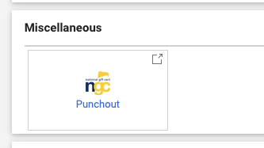
- Click on “Electronic Gift Cards” in the upper left corner.
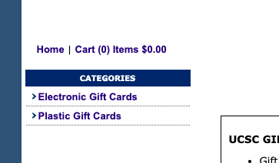

- From here, select which gift card was requested and press the “Add” button

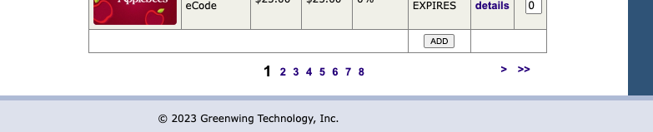

- You will then be taken to your cart to check out. Enter in your first and last name and email, NOT THE RECIPIENTS.
- From this page, click proceed to checkout in the upper right corner.

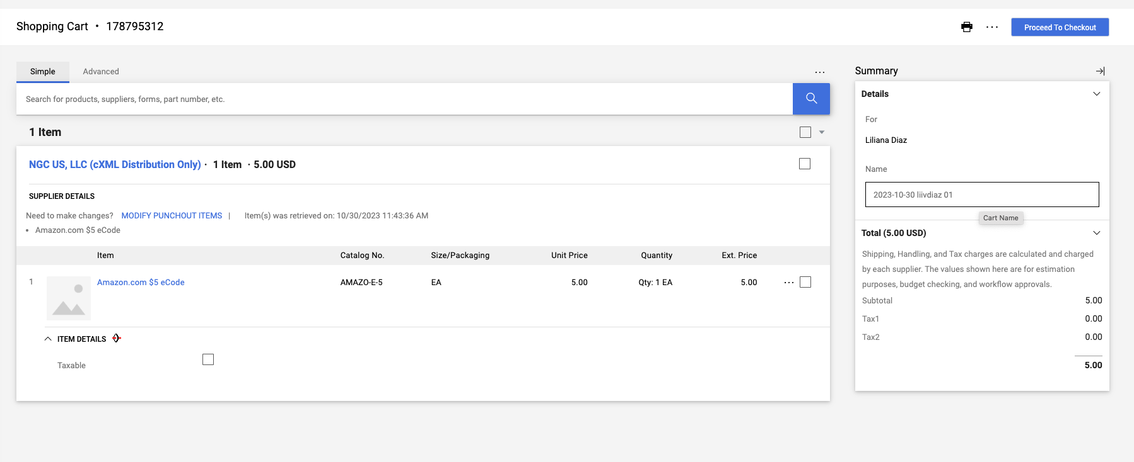
- On the next page, you will need to upload a combined PDF of the Spot Award nomination form and the email approvals from the chair and April. Upload the PDF on the website here:
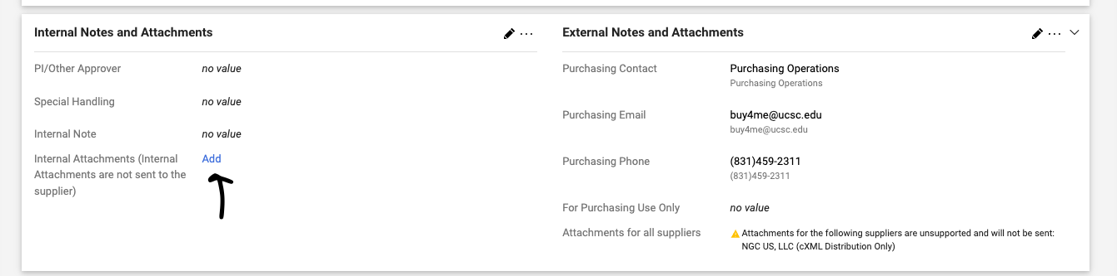
- Next, you will need to input the funding here:
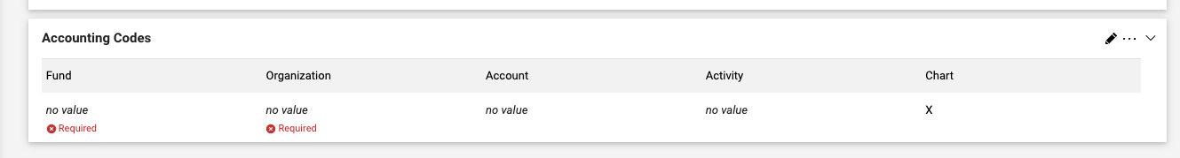
- Once the PDFs and funding have been inputted, you can press the submit button in the upper right corner.

- You will get a few emails from CruzBuy (“ngcecodes”) over the next few days confirming the processing, you can ignore those but the email you want to look out for looks like this:
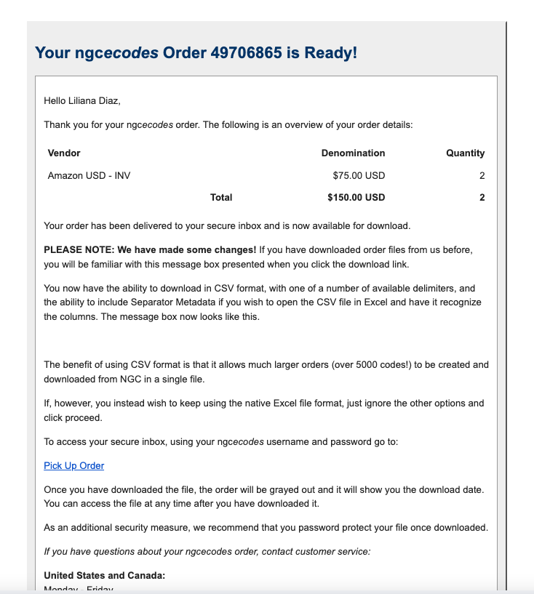

- This email means the gift card is ready. Click on “Pick up Order” link.

- Once you login, click “Download eCode Order”. I prefer downloading in excel.

- Once the excel downloads, open the file and reply to the Spot Award email thread where they specified their preference (just them, nominator not cc’d) and paste the “Raw Code” and a Pin if one is listed (not always). We prefer you paste the information on the email rather than attaching the excel file as it can be confusing.

- Once you send the recipient their gift code, the process is complete!

